New smartphone? Recycle one as well
Johan Rodenhuis, Sustainability advisor category ICT Work Environment, stimulates sustainability within Dutch central government. The fact that smartphones were being discarded after just 2 to 2.5 years was a terrible waste, he felt. That is why he started an e-waste compensation project. For every smartphone bought by central government, another was saved from the mountain of waste in Africa.

How can we make this more sustainable?
The longer a smartphone is being used, the more sustainable it is. Johan: ‘It saves quite a lot of CO2 emissions if you use your phone for 4 years instead of 2. Circularity is becoming an increasingly important aspect of ICT procurement. That is why we take stock of each product group to see how we can improve sustainability. In data centers the biggest gains can be made with energy efficiency, i.e. in the use phase. For smartphones, on the other hand, the main environmental impact is in the production phase. That is precisely why lifetime extension has a lot of impact, for example by providing software and security updates for a longer period of time, increasing repairability or reusing the product. However, not buying new products will have the biggest impact, as this reduces production. So you should ask yourself: do I really need this product? Having one IT-device for both work and private use, instead of two, is also an interesting possibility.’

Faster, better, newer
ICT is a young market, where everything still has to be faster, better, newer. Johan: ‘As consumers, we replace a smartphone much faster than any other product. We feel it is perfectly acceptable to buy a second-hand car. But we prefer to buy a new smartphone, because we think it is more reliable. Fortunately there is a growing awareness of the need to make our phones last longer. Why don’t we buy a refurbished or remanufactured one? That is a change of culture. We are in the middle of that transition.’

Shredding smartphones
Central government wants to contribute to this transition, but safety aspects often prevent reuse. Johan: ‘when a laptop is end-of-life from a business point of view, it is cleared and made available on the market again. Wipe, remove the hard disk, and done. For smartphones this is much harder to do. Although you can destroy a great deal of data, on some devices fragments of metadata remain. For safety purposes, smartphones were therefore shredded and the raw materials were recycled.’ However, using a device for a longer period of time or reuse of a government device by non-profit organizations or consumers is much more effective, according to Johan. ‘I personally think that shredding a device so soon is unacceptable.’
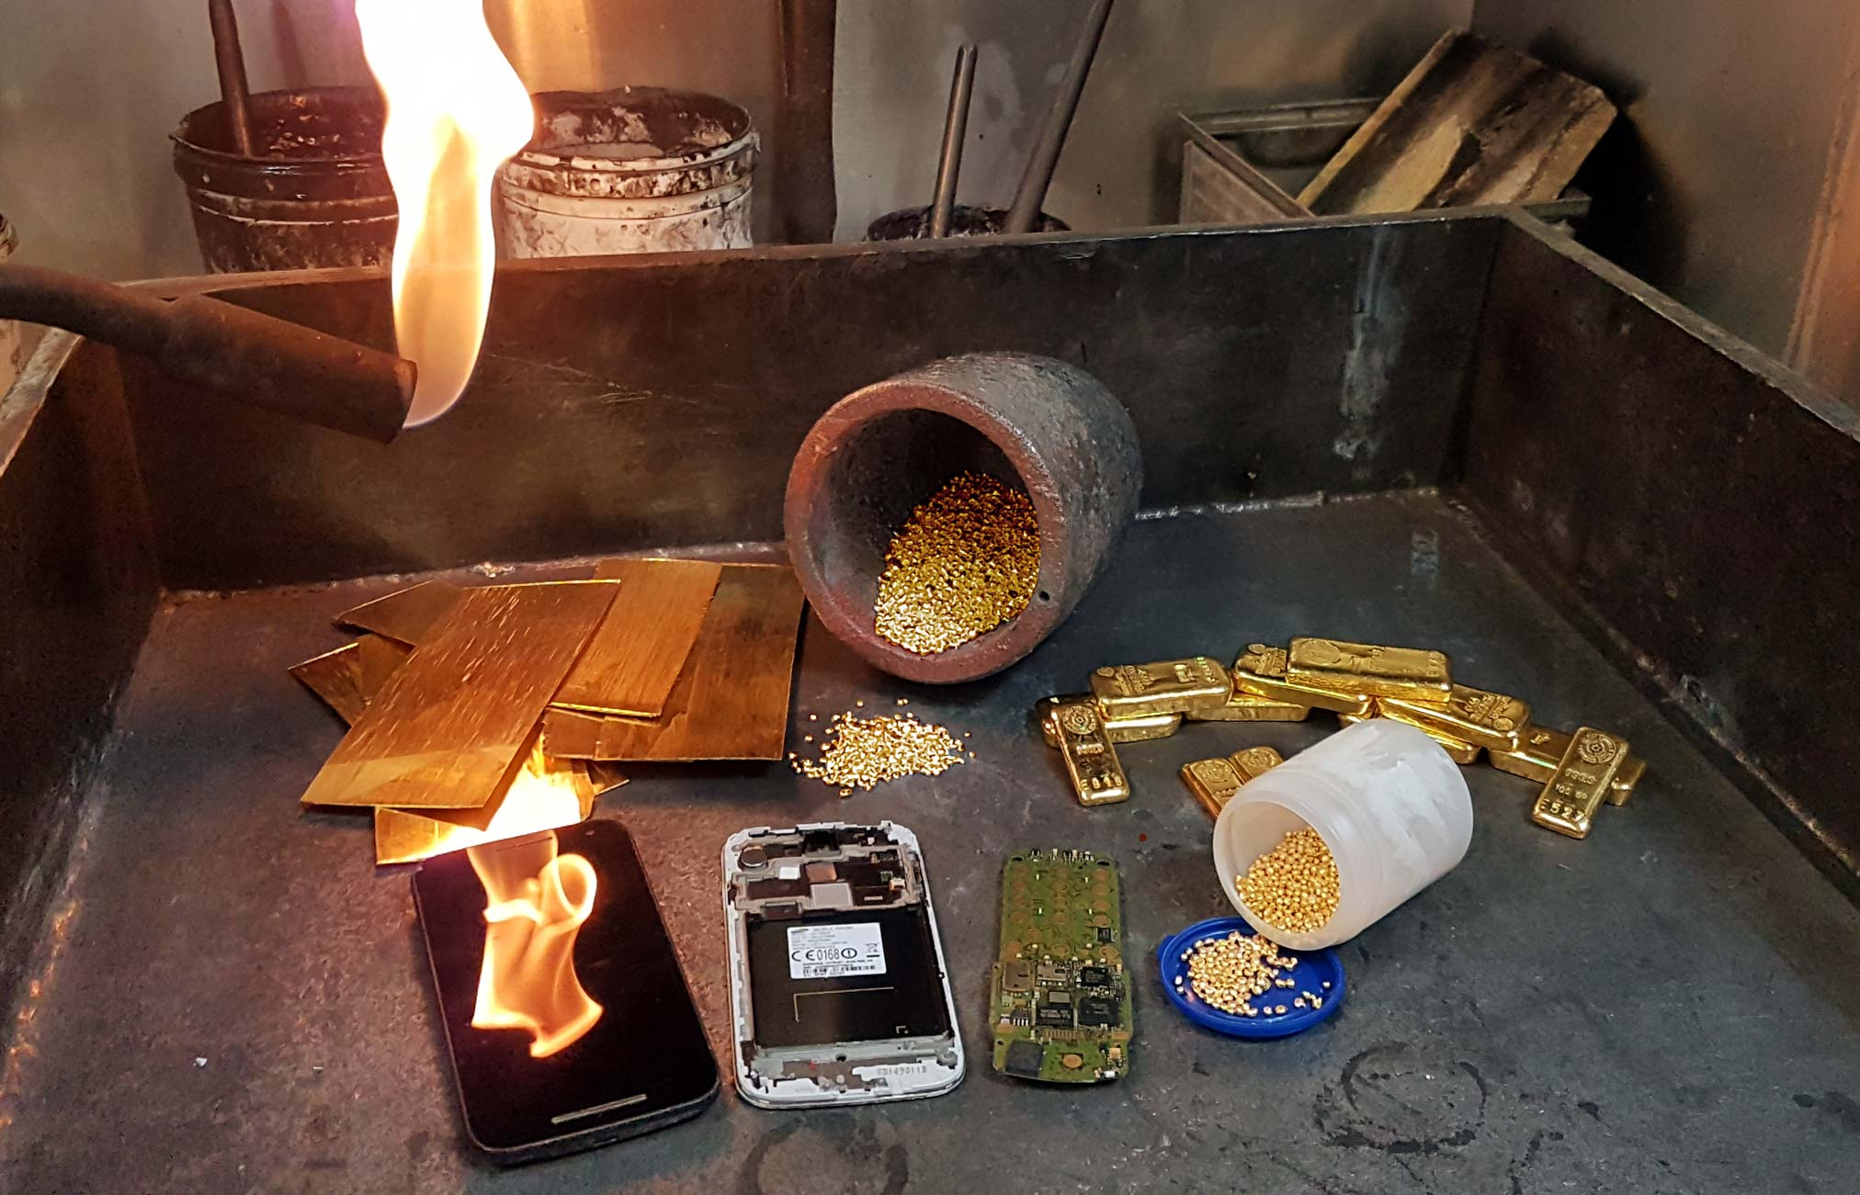
Figure 1‘A smartphone contains a large amount of capital: cobalt, gold, aluminum, indium’ - Johan Rodenhuis

Reuse is still in its infancy
Extending the life of smartphones in central government is still in its infancy, but the trend is encouraging. Johan: ‘We see that the useful life within the government bodies is growing from 2,5 to 3 years and we are aiming for 4 years. That should be easy, because more and more, new smartphones are better equipped to last longer. Reuse will be easier as a number of devices currently on the market are compliant with our requirements regarding security and data destruction. Operational lease, or ‘smartphone as-a-service’, is also growing more popular. This includes a guarantee that a device will get a second life when it is returned. So we are moving in the right direction, but there is still a long way to go.’

Closing the Loop
It will take a while before reuse will be common. What can we do meanwhile? Johan: ‘Mid-2018 we came up with the idea of waste-compensation. We started a two-year pilot, in which for each new smartphone purchased by central government, one end-of-life device would be recovered for recycling, in Africa. A smartphone contains a large amount of capital: cobalt, gold, aluminum, indium.’ The young organization Closing the Loop was contracted to carry out the waste-compensation; they make our new devices waste-neutral.

Local employment
Closing the Loop has a network of collection points in various African countries. The scrap phones are collected by local people in a responsible manner. They receive a fair remuneration per phone. When they have filled a container, Closing the Loop ships the phones to the certified processor in Europe, where they are disassembled. Valuable materials are resupplied to European manufacturers. In this way they remain part of the cycle. Johan: ‘We were able to start quickly. We had a good idea. And we had money from the climate envelope, a financial incentive for sustainable projects.’

57.000 phones have been compensated
The government purchases approximately 30.000 smartphones every year. In the space of two years about 57.000 smartphones have been compensated. Johan: ‘We are very interested to know how much raw material and CO2 reduction we have achieved with this project. We are now waiting for the results. I don’t think it will be a 1-on-1 match, but we will be able to show the impact. It is and will remain my ambition that we use smartphones and other electronic devices for a longer period of time. But this is a great and pragmatic additional contribution which does have impact.’

Disassembly is sustainable
Johan intends to use both e-waste and CO2 compensation in broader perspective in future tenders. ‘The market is clearly evolving and developments are taking place at a rapid pace. We have been acting as ‘launching customer’, but it is expected that in future hardware suppliers will provide compensation themselves. Also, a new SPP criterion for waste compensation has been introduced recently, which is linked to independent certification. That makes it easier to include compensation in new tender processes.’ In addition, Johan keeps stressing the importance of avoiding unnecessary consumption and of lifetime extension. ‘Make sure to purchase products that last a long time, can be repaired and receive support for a long period of time. Such a product may be more expensive, but if it lasts twice as long the investment will repay itself and you are acting eco-friendly as well.’
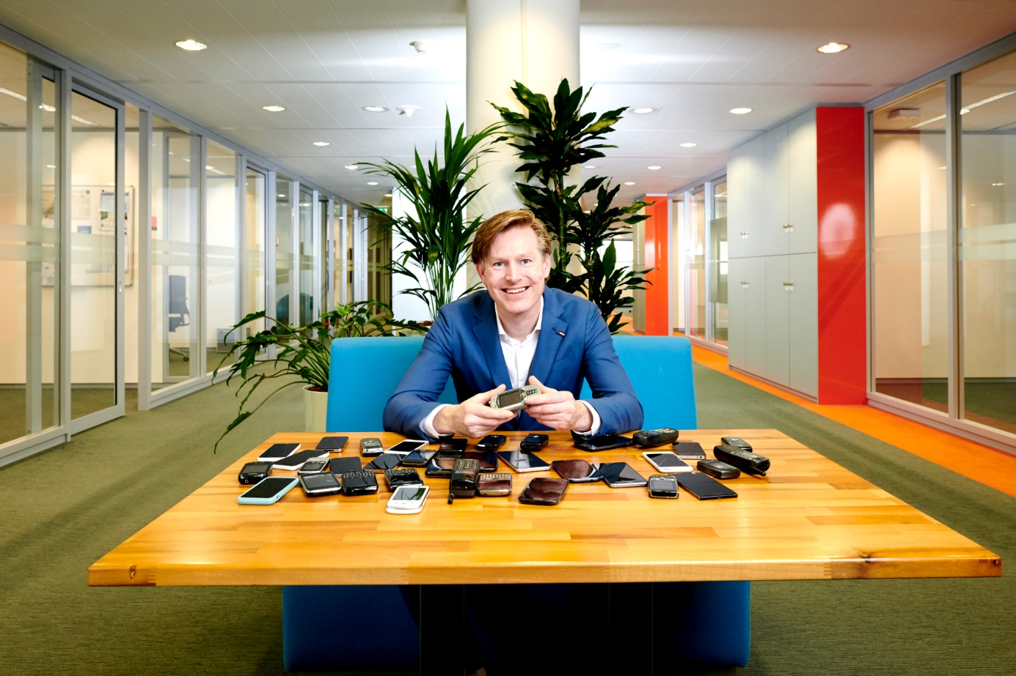
Figure 2 Johan Rodenhuis is Sustainability advisor for category ICT Work Environment Central Government - Ministry of Economic Affairs and Climate Policy

